University of Pittsburgh at Johnstown
Department of Electrical and Computer Engineering
EE 1195 / COE 1195 Engineering Practice and Professional Development
Monthly Progress Report - 03

Cycle Statistic Tool

Date: April 06, 2021

Submitted By: Jacob Hoffman
Cody Klingler

Instructor: Professor Christopher Gabany
Dr. Maddumage Karunaratne

Project Description:
The Cycle Statistic Tool is a data recording device which will be attached to the frame of a bicycle. In this position, several electronic components may be used to record statistics about a user’s cycling trip. The Cycle Statistic Tool will transmit data to a companion application that is installed on a user’s smartphone. This application will utilize the collected information to provide records of a user’s cycling sessions in the form of graphs and charts that enable the user to improve their cycling skills. An appropriate microcontroller will be used as the primary board to connect all sensors and for operation of the device. A secondary microcontroller will be attached to the pedal shaft to wirelessly relay data from this position to the primary board. Live data will be displayed to the user by a display panel connected to the primary board. The entire device will require a casement which will be modeled and 3D-printed. This casement should be weather-proof and able to connect to the frame/handlebar of a bicycle universally.

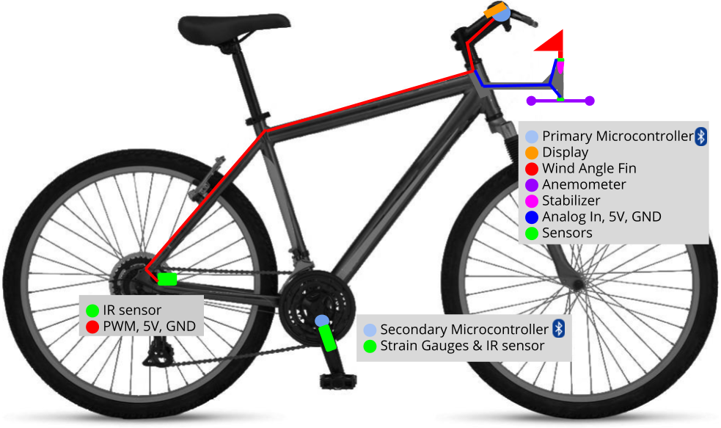
Figure 1: Project Layout

Time Schedule:
Table 1 presents the task division table which provides appropriate start dates, end dates, and estimated time duration for each task to complete the Cycle Statistic Tool within the appropriate time frame. The completed tasks are highlighted green, in progress tasks highlighted yellow, and tasks that have not yet begun highlighted red.

Table 1: Task Division Table
Critical | Task Description | Duration | Start Date | End Date
 | Research Components | 6 hrs | Fri 1/15/21 | Sat 1/16/21
• | Design System | 6 hrs | Mon 1/18/21 | Wed 1/20/21
 | Design Display UI | 4 hrs | Fri 4/2/21 | Sat 4/3/21
 | Design Wind Sensing Unit | 9 hrs | Sun 3/7/21 | Fri 3/12/21 |  | Completed
 | Assemble Wind Sensing Unit | 13 hrs | Mon 4/12/21 | Mon 4/19/21 |  | In Progress
 | Design Mobile Application | 12 hrs | Wed 2/10/21 | Wed 2/17/21 |  | Not Started
 | Test Bluetooth Communication | 12 hrs | Wed 4/7/21 | Mon 4/12/21
 | Research Bluetooth | 6 hrs | Fri 2/19/21 | Sat 2/20/21
 | Code Microcontrollers | 76.5 hrs | Fri 1/29/21 | Sat 3/13/21
 | Test Components | 12 hrs | Mon 1/25/21 | Sat 1/30/21
 | Mount Hardware | 12 hrs | Sun 3/14/21 | Sat 3/20/21
 | Test Accuracy of Calculations | 14 hrs | Wed 4/7/21 | Wed 4/14/21
 | Weatherproof | 3 hrs | Wed 4/14/21 | Wed 4/14/21
 | Test Durability | 6 hrs | Fri 4/16/21 | Sat 4/17/21
 | Research Data Collection | 8 hrs | Wed 3/17/21 | Sat 3/20/21
 | Research Data Analysis | 6 hrs | Wed 3/17/21 | Fri 3/19/21
• | Research Mobile Development | 10 hrs | Wed 1/13/21 | Wed 1/20/21
• | Code Mobile Application | 78 hrs | Fri 2/19/21 | Sat 4/3/21
• | Debugging | 27 hrs | Mon 4/5/21 | Mon 4/19/21

Green: Completed Tasks, Yellow: Tasks In Progress, Red: Incomplete Tasks
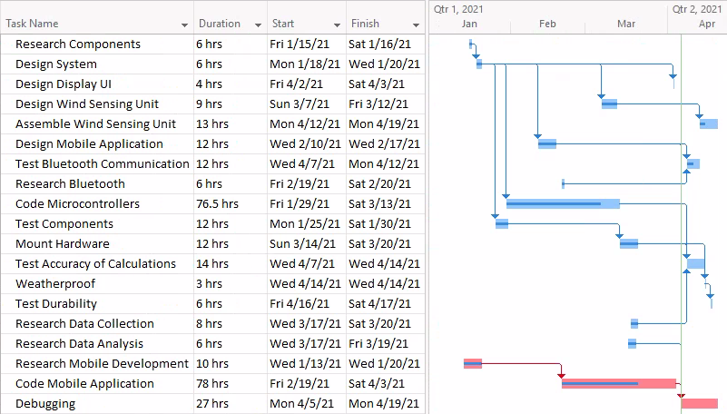
Figure 2: Gantt Chart

For the hardware path during the month of March, the majority of the time spent was working with strain gauges due to the steep learning curve involved in their usage. The steps taken for this includes filing the crank arm, mounting the gauges, soldering the gauges, and assembling circuit. The strain gauges often broke or were inaccurate and needed to be replaced. Repetitive testing was needed to get the process correct. Excess time was spent soldering and assembling the strain gauge circuit because the load cell amplifier that is used to measure the strain values had its gain set dynamically based on the input. This was causing the strain measurement to read at its maximum value, which was misidentified as a hardware issue. The final design of the circuit was changed to a full bridge—implementing four gauges instead of two—so that if one were to fail, the design could be easily converted back to a half bridge, thus eliminating the need to remount gauges. During the last week and a half of the month, time was spent rewriting the microcontroller code to make it easier to adjust. The new code is event-based and allows the programmer to set timers that update the statistics asynchronously. The display UI was also designed and programmed during the last week of March. The handlebar mounted display can be seen in Figure 2. Finally, a few of the tasks in the GANTT chart have been continually set back, including creation of the wind-sensing unit and testing bluetooth.
The project team continued to code the mobile application during March. Jacob spent the majority of the month on the companion application’s bluetooth LE (BLE) connectivity. The Plugin.BLE (https://github.com/xabre/xamarin-bluetooth-le) package was used as a framework for the implementation of this functionality. There is unfortunately no native framework in Xamarin Forms for connecting to the native bluetooth interfaces on Android and iOS. After trial and error, a design that allows for searching, connecting, disconnecting, and reading characteristics (properties) from the Cycle Statistic Tool was designed. The companion application will now automatically launch the Trip page. On appearing, the page will check to see if a bluetooth device is currently connected to the application. If it is not, a list page will launch and display all nearby devices. When the user selects the Cycle Statistic Tool device from the list, the application will connect and re-launch the Trip page. We have yet to test this code via connection between the devices, but it all compiles. Additionally, a GATT attribute table was created to represent the service and corresponding characteristics that will be transmitted across BLE. The GATT attribute table can be seen in Table 3. Finally, the Trip page UI layout was programmed and implementation of the data binding between the UI and the actual view model (logic and data models) of the application began. The current Trip page UI is shown in Figure 3.

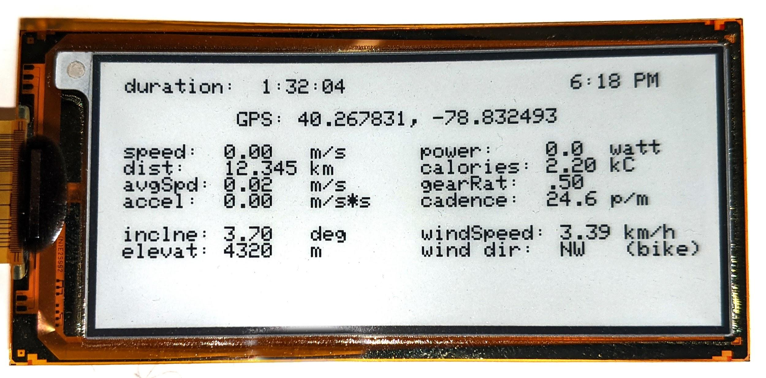
Figure 2: Handlebar Mounted Display
Table 2: GATT Attribute Table
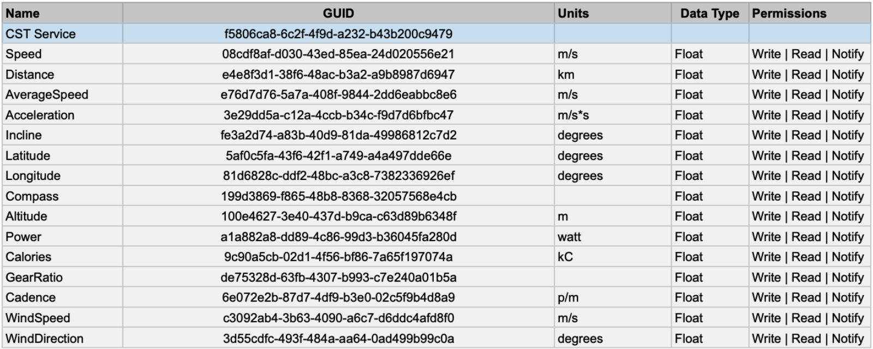

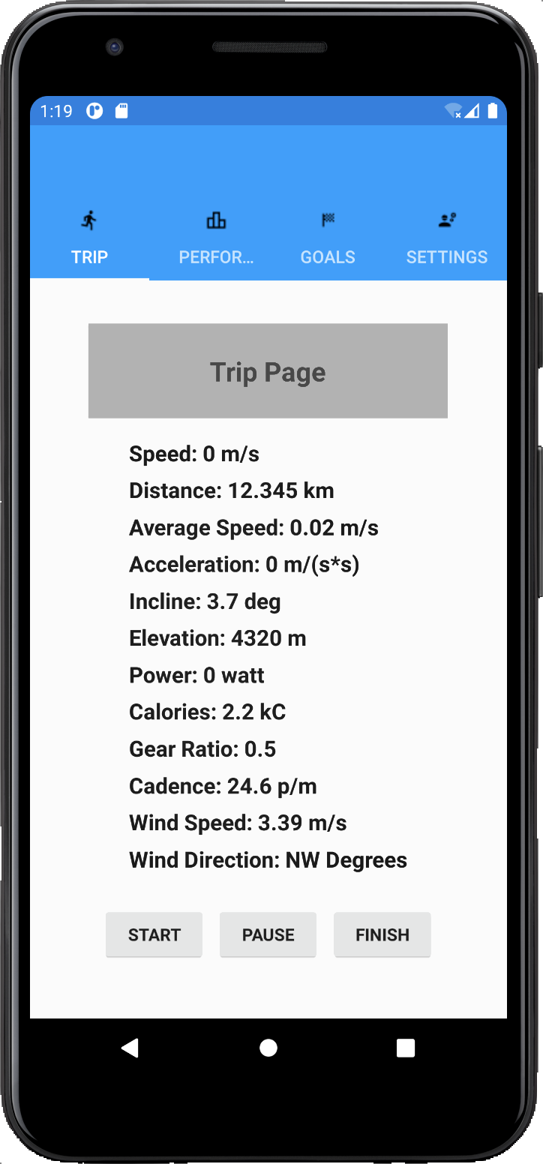
Figure 3: Trip Page UI
Bill of Materials:
During the month of March, some updates to the bill of materials were made. In Table 3, the changes made to the bill of materials are highlighted in yellow. Some miscellaneous purchases have yet to be made, such as mounting brackets for the hardware and materials for constructing the stabilizer component of the wind angle fin.

Table 3: Bill of Materials
Part Number | Product Name | Quantity | Actual Cost | Description
ABX00027 | Arduino Nano 33 IOT | 2 | $18.40 | Microcontrollers with Bluetooth
Adafruit PID: 4224 | Adafruit eInk Breakout Friend with 32KB SRAM | 1 | $8.50 | Memory buffer for eInk display
Adafruit PID: 4262 | 2.9" Flexible Monochrome eInk | 1 | $26.95 | Low power eInk display
C000160 | Grove - Infrared Reflective Sensor V1.2 | 2 | $5.90 | Measures angular frequency
CEA-06-125UT-350 | Micro Measurements Strain Gages | 1 | $29.99 | Measures sheer force
HX711 | Load Cell Amplifier / ADC | 1 | $9.95 | Reads strain from gauges
176SF1D-L394 | Honeywell Precision Continuous 10K Potentiometer | 1 | $22.95 | Measures wind angle
PA1010D | Adafruit Mini GPS | 1 | $29.95 | 10Hz GPS module
LP785060 | Lithium Ion Polymer Battery - 3.7v 2500mAh | 1 | $14.95 | Power for Microcontrollers
 | Metal Crank Arm | 1 | $13.63
 | Misc |  | $165.87 | Jumpers, Headers, Solder, additional strain gages, glue, catalyst, etc.
 | Shipping |  | $53.75
 | TOTAL |  | $400.79

Unexpected Items:
Cody had to order three more sets of strain gauges to mount on the crank arm. This was necessary because the strain gauges are extremely sensitive. Many of the gauges stopped working unexpectedly, or needed to be remounted in more optimal positions. Additionally, a load cell amplifier/ADC, that is to say the HX711, needed to be purchased to measure the strain on the gauges. The arduino’s GPIO pins are not sensitive enough and have too much noise to measure such precise changes in resistance. Because the HX711 requires a 5V input and our microcontrollers operate at 3.3V, the design of the Cycle Statistic Tool was changed to implement a 5V battery bank instead of the 3.7V battery that we had initially planned to use on the crank arm. Miscellaneous materials such as spools of wire and protoboards were also purchased. For the hardware, there are currently no ongoing issues.
Jacob spent an unexpectedly large amount of time on the implementation of BLE. Additional time was also spent on coding the mobile application because of complications with implementing the data binding between the target UI and the source data object (representing the recorded data read from the Cycle Statistic Tool). These are both still ongoing unexpected items for the project.

Customer (Functional) Requirements and Engineering Specifications Targets:
The Engineering Specifications Table is presented in Table 4. There were no changes made to the table. At this point in time, the “cost of materials” and the “setup steps before use” engineering specifications have been evaluated. The majority of the project team’s testing will be performed during the “testing accuracy of calculations” and “testing durability” task on the GANTT chart. The total cost of materials has increased to $400.79. A breakdown of the bill of materials and updates to it during the month of March are shown in Table 2. The current cost is still below the engineering specification target of $500. Due to the majority of the functionality for connecting the CST hardware to the smartphone application has been completed, the setup steps before use target has been approximated to four steps (turn on CST device, turn on smartphone application, select CST as BLE device to connect to from device list, select start on the Trip page to begin a trip). For this engineering specification, the target was three steps with a threshold of six steps.

Table 4: Engineering Specifications Table
Engineering Specification | Unit | Direction | Target | Threshold
Size  Ease of use | m³ | ▼ | .2 | .5
Overall Accuracy of Sensors  Accuracy of measurements  Price  Battery life | % | ▲ | 90 | 80
Accuracy of Power Metric  Accuracy of measurements  Price  Battery life | % | ▲ | 90 | 75
Accuracy of Speed Metric  Accuracy of measurements  Price  Battery life | % | ▲ | 95 | 85
Cost of Materials  Accuracy of Measurements  Price  Battery life  Durability | $ | ▼ | 500 | 700
Weatherproof  Price  Weatherproof  Durability | IP | ▲ | 23 | 54
Battery Life  Price  Battery life | hr | ▲ | 12 | 3
Lifespan  Weatherproof  Durability | mo | ▲ | 24 | 12
Time to View Metrics in App  Statistic utilities in app | s | ▼ | 2 | 6
Setup Steps Before Use  Attaches universally  Ease of use  Ease of setup |  | ▼ | 3 | 6
Steps to Attach to Bike  Attaches universally  Ease of use  Ease of setup |  | ▼ | 10 | 20

